## **Purchase Cancellation Process**

### **Current Scenarios of Purchase and It’s Transfers**

* In Odoo's default process, when a product purchase follows a two-step receipt process, the system generates two transfers:
  + First transfer: Partner/Vendor to WH/Input
  + Second transfer: WH/Input to WH/Stock

#### **Default System Behavior:**

* If both transfers are in **Draft** status and you cancel the purchase order, the system allows cancellation, and both transfers are also cancelled.
* If both transfers are in **Done** status and you attempt to cancel the purchase order, the system prevents cancellation and raises a warning.
* If the **first transfer** (Partner/Vendor to WH/Input) is **Done** while the **second transfer** is still in **Draft**, the system also raises a warning and does not allow cancellation.

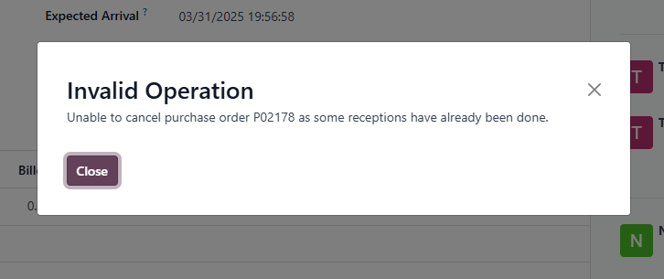

* If a return is created and validated for the first transfer while the second transfer remains in **Draft**, it results in a pending second transfer that has no further process, causing confusion.

### **Solution for Purchase Order Cancellation and Its Transfers**

* To resolve the issue of pending internal transfers, we made changes to ensure that if all products from the first transfer are returned, the corresponding internal transfer is also cancelled when the purchase order is cancelled. The following rules apply:

#### **Cancellation Rules:**

1. If you cancel a purchase order while both transfers are in **Waiting** or **Draft**, the system allows cancellation.
2. If the **first transfer** is **Done** and the **second transfer** is in **Waiting** or **Ready**, the system does **not** allow cancellation.
3. If both transfers are **Done**, the system does **not** allow cancellation.
4. If a return is initiated but **not validated**, the system does **not** allow cancellation.
5. If all stock from the **first transfer** is returned, but the **second transfer** (WH/Input to WH/Stock) is not validated, then cancellation of the purchase order is **mandatory**. In this case, the system will automatically cancel the second transfer when the purchase order is cancelled.
6. If both transfers are **validated**, and both transfers are **returned and validated**, the system allows purchase order cancellation.
7. If a **vendor bill** is created and all products are returned, attempting to cancel the order will raise a warning prompting the creation of a **credit note**.

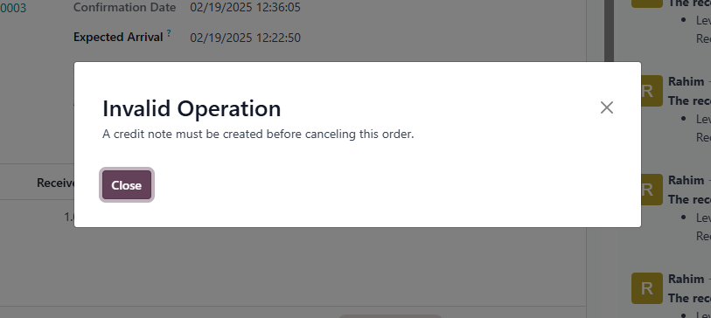

* In this case, you must first create and confirm a **credit note** for the vendor bill before proceeding with the order cancellation.

### **Key Functionality:**

* The primary goal of this update is to **automatically cancel draft internal transfers** when the first transfer has already been returned. However, to achieve this, it is **mandatory** to cancel the purchase order after returning all stock from the first transfer.
* After cancellation, the purchase order **cannot** be reset to draft.